SQL Inner Join Practice

For each of the following questions, indicate on the ERD the columns used in the various clauses for the required query. Mark them with Select (S), From (F), Where (W), Group-By (G), Having (H), and Order-By (O). Mark Joins by a (J) on the relationship line.

**#3. Select the Club ID's and the Student full names that are in them**

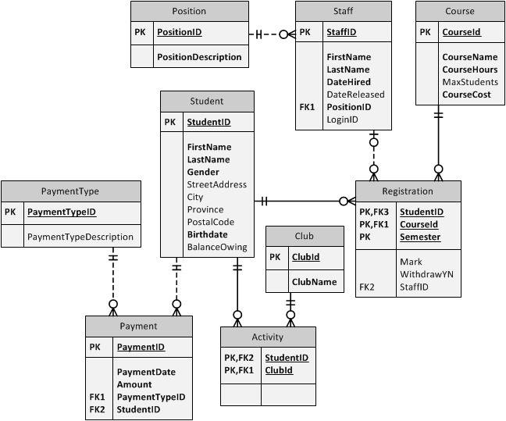

**#7. What Staff Full Names have taught Networking 1?**



**#8. What is the course list for student ID 199912010 in semester 2001S. Select the Students Full Name and the CourseNames**



**#9. What are the Student Names and courseID's that have Marks >80?**

